Experiment No 2

Title:
Implementing Animations in the GrocerySpot App

Objective:
To explore animations and create visually appealing UI effects in the GrocerySpot mobile application.

Theory:

1)Building an app that incorporates animations:
Animations play a vital role in enhancing user experience and engagement in mobile applications like GrocerySpot. Here are several reasons highlighting the importance of animations in the app:

Visual Appeal:
Animations add an attractive element to the app, making it visually appealing and engaging for users.
Smooth and well-designed animations contribute to a modern look, capturing users' attention.

User Engagement:
Animations can guide users through various interactions, making the app more interactive and engaging.
Users are more likely to explore the app's features and functionalities when animations provide visual feedback.

Intuitive Navigation:
Animated transitions between screens and elements contribute to a more intuitive navigation experience.
Animations help users understand the flow and hierarchy of information within the app.
Enhanced User Feedback:
Animations can communicate changes in states or actions, providing clear feedback to users.
Users receive visual cues about the outcome of their interactions, reducing confusion.

2)Experimenting with different animation types such as fade-ins, slide transitions, or rotation effects:

In the GrocerySpot app, I experimented with various animation types to enhance the user experience. For example, I utilized fade-in animations to the “Welcome To Grocery Spot” and the “The Grocery Spot Logo” details when users browse through the catalog. This creates a visually pleasing effect and draws attention to the products.

Additionally, I implemented slide transitions between different screens, such as the login and signup screens, to create a seamless flow between app sections. This enhances the overall navigation experience and makes the app feel more cohesive.
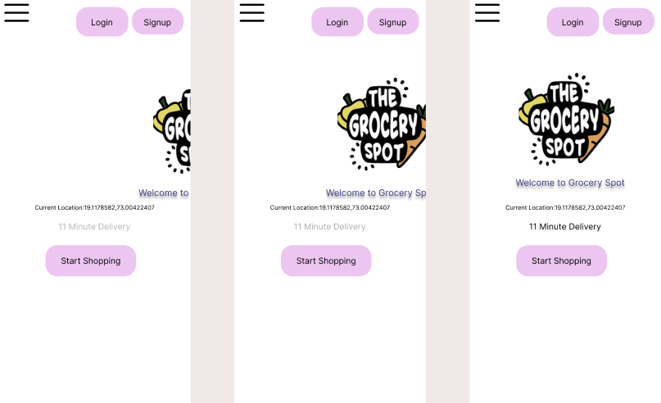

3)Applying animations to widgets, screens, or specific UI elements to enhance the user experience:

In the checkout process of the GrocerySpot app, I applied animations to specific UI elements to improve the user experience. For instance, I used the Animated Opacity widget to animate the visibility of the payment details section. When users proceed to the checkout screen, the payment details section smoothly fades into view, providing a seamless transition and reducing visual clutter.

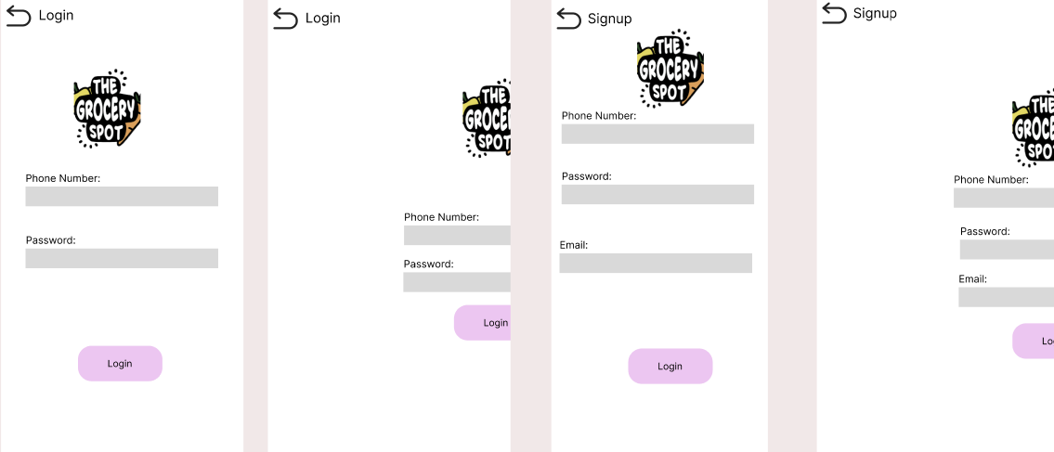

Conclusion:

In conclusion, animations are a powerful tool for enhancing the user experience in mobile applications like GrocerySpot. By strategically implementing animations, we can create a visually appealing, engaging, and intuitive app that delights users and encourages interaction. Through experimentation and thoughtful design, we can leverage animations to elevate the overall user experience and distinguish our app in the competitive market.

